**ADS- CLIMATE ANALYSIS**

**INTRODUCTION**

The focus of this assignment is to get an idea about the movement of indicators related to climate and economy with the passage of time. Multiples countries across the globe are selected for analysis. An inter-country level analysis has been conducted to form an opinion about the association of the different indicators.

**ANALYSIS**

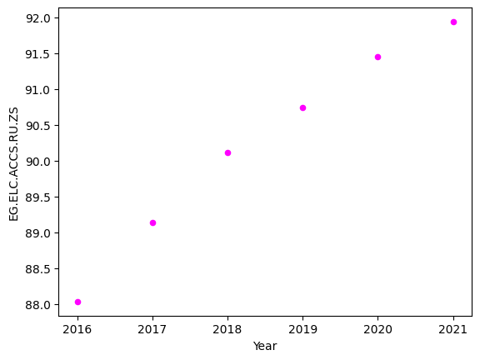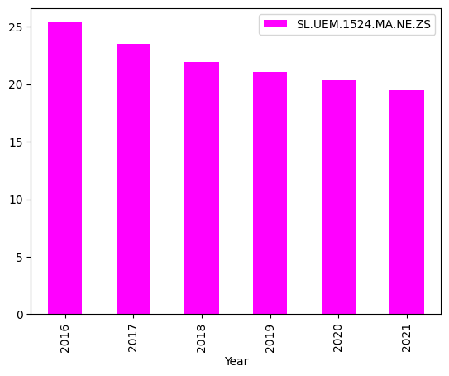

The above figure is a scatter plot visualization which shows that the trend of population in Pakistan has increased significantly since the year 2016.

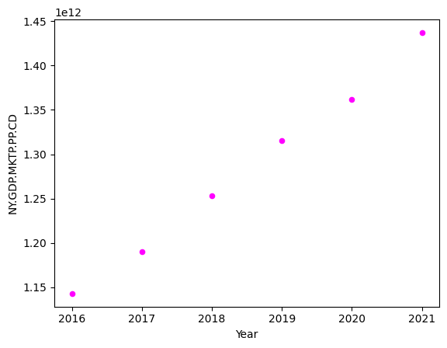

The above figure is a scatter plot visualization which shows that the trend of GDP in a PPP basis for Australia has increased significantly since the year 2016.The above figure is a bar plot visualization which shows that the trend of male youth unemployment in France has decreased significantly since the year 2016.

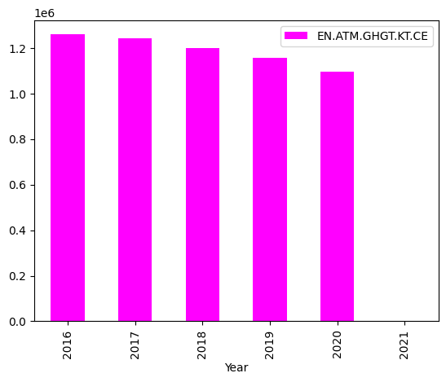

The above figure is a bar plot visualization which shows that the trend of greenhouse gas emissions in Japan has decreased significantly since the year 2016.

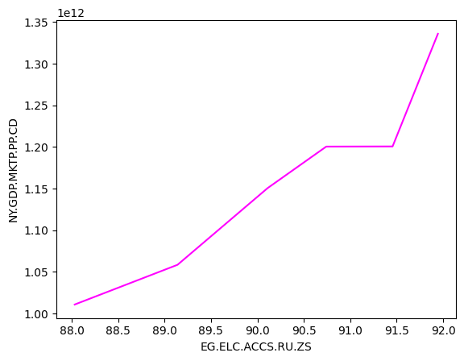 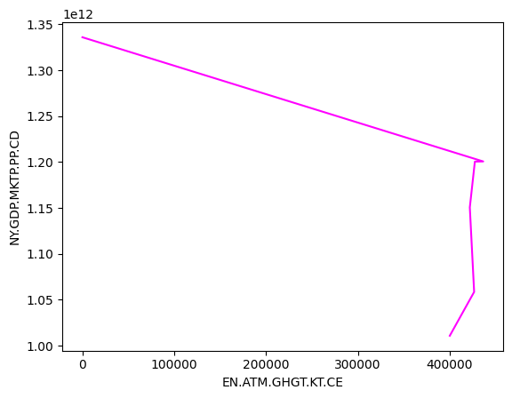

The inter-country analysis for Pakistan shows that there is a direct association between the rural electricity access available and the current GDP in a PPP basis.

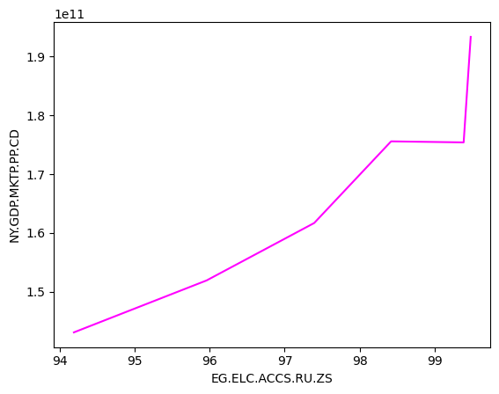

The inter-country analysis for Bulgaria shows that there is a direct association between the rural electricity access available and the current GDP in a PPP basis.

**CONCLUSION**

* The total population in Pakistan has increased since the year 2016
* The male youth unemployment in France has decreased significantly since the year 2016.
* The GDP in a PPP basis for Australia has increased since the year 2016
* The greenhouse gas emissions in Japan has decreased significantly since the year 2016.

The inter-country analysis for Pakistan shows that there is an indirect association between the current GDP in a PPP basis and the greenhouse gas emissions.

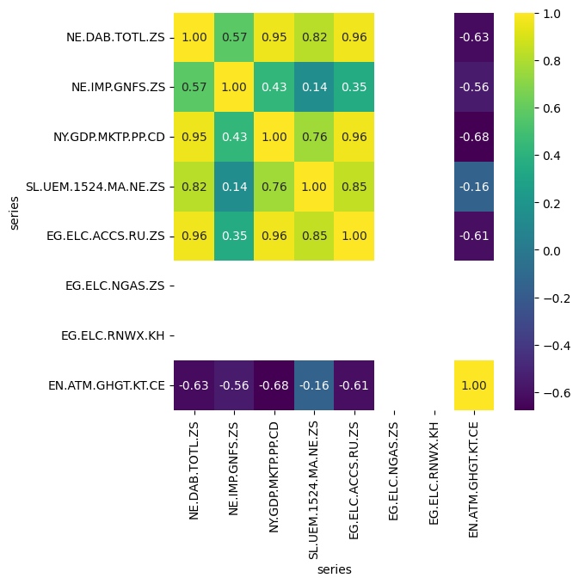

The heatmap visualization for India indicates a strong positive correlation between total expenditure and current GDP, PPP. There is a negative correlation between greenhouse gas emissions and total expenditure in India

* The inter-country analysis for Pakistan shows that there is a direct association between the rural electricity access and current GDP, PPP. In Pakistan, there is an indirect association between the current GDP, PPP and the greenhouse gas emissions.
* From the heatmap, it is observed that strong positive correlation between total expenditure and current GDP, PPP is present for India. A negative correlation between greenhouse gas emissions and total expenditure is there in India.